Project

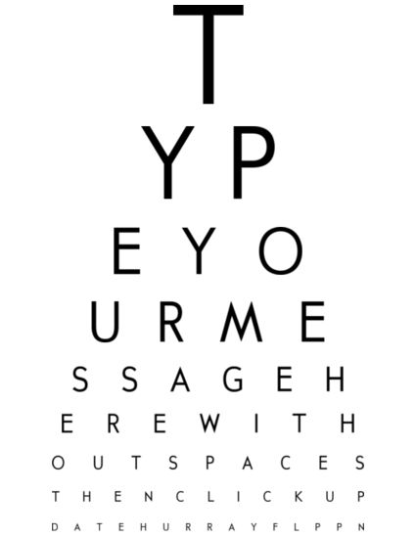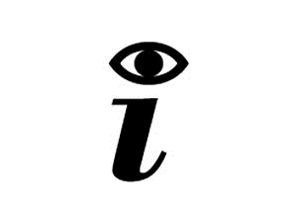 TEST

**Grupo 6:**

Fábio Magalhães – A75030

Rui Carvalho – A76279

Index

Problem Statement 3

Constraints 3

Technical Constraints 3

Functional Requirements 3

Non-Functional Requirements 4

Hardware Specifications 4

Software Specifications 4

System Overview 4

Gantt Chart 5

Problem Statement

In today society mankind is constantly using digital devices, that are affecting, negatively, vision health. It's been a concern for the past years to fight this era’s side-effect. To get yourself diagnosed, you must go to a doctor, which in public healthcare means a long wait and sometimes may be costly.

The Project’s goal is to design a tool to help diagnose irregularities in human vision, such as astigmatism, near-sightedness, and colour blindness. With only one device the user will be able to self-diagnose in an interactive and fast way.

We will have a screen showing images, that the user must identify. The device will recognise the answer and evaluate it. In the end of the test it will give you a result of how good or not your vision is.

Constraints

* Budget must be minimal.
* Project developed by a team of two.
* Project must meet the final deadline.

Technical Constraints

* STM32F4-DISCOVERY board
* Keil uVision MDK-ARM
* Digital Signal Processor (DSP)
* FreeRTOS
* Minimum of three sensors

Functional Requirements

* Display the vision test on the TFT screen.
* Detect user interaction.
* Measure the distance between the device and the patient.
* Check suitability of the ambient light.
* Recognise speech input data.
* Show malfunctions on the display.
* Give audio signals.

Non-Functional Requirements

* Low Cost and low power.
* User-friendly interface.
* Small and portable.
* The system must have low latency.
* As outputs will have the TFT display.
* As inputs will have touchscreen, microphone, distance, and light.

Hardware Specifications

* Stm32f4 discovery
* Light sensor
* Ultrasonic distance meseaurement2
* MEMS digital microphone
* TFT w/touchscreen

Software Specifications

* Keil uVison MDK-V5
* FreeRTOS
* C Language

System Overview

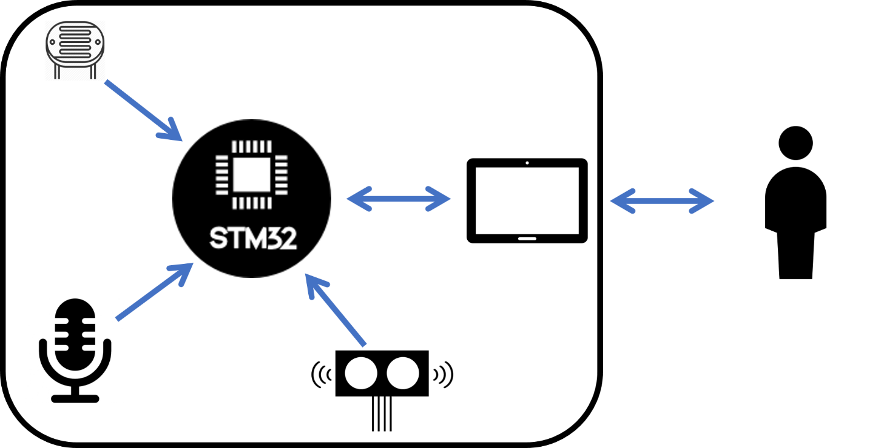

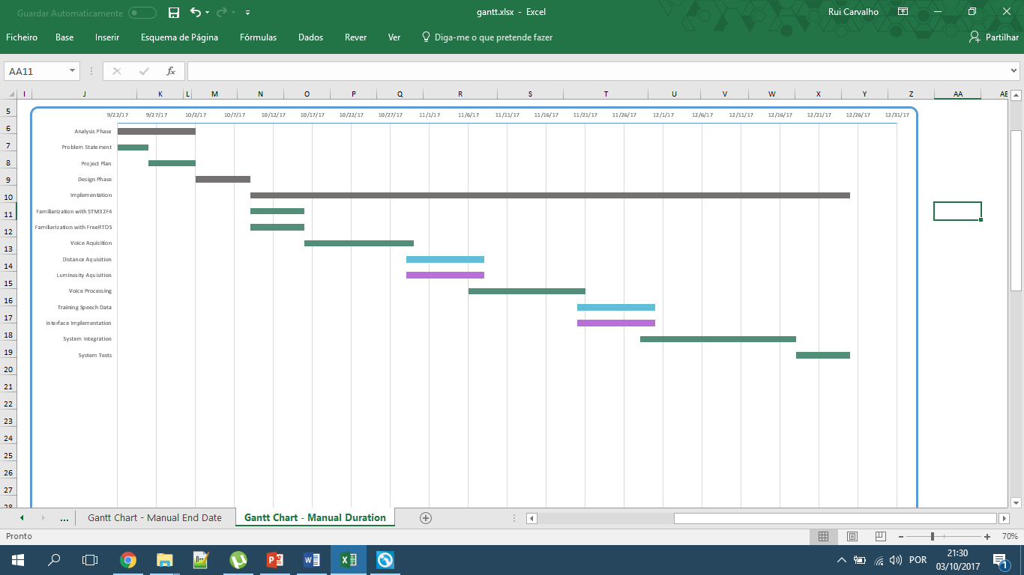Gantt Chart

